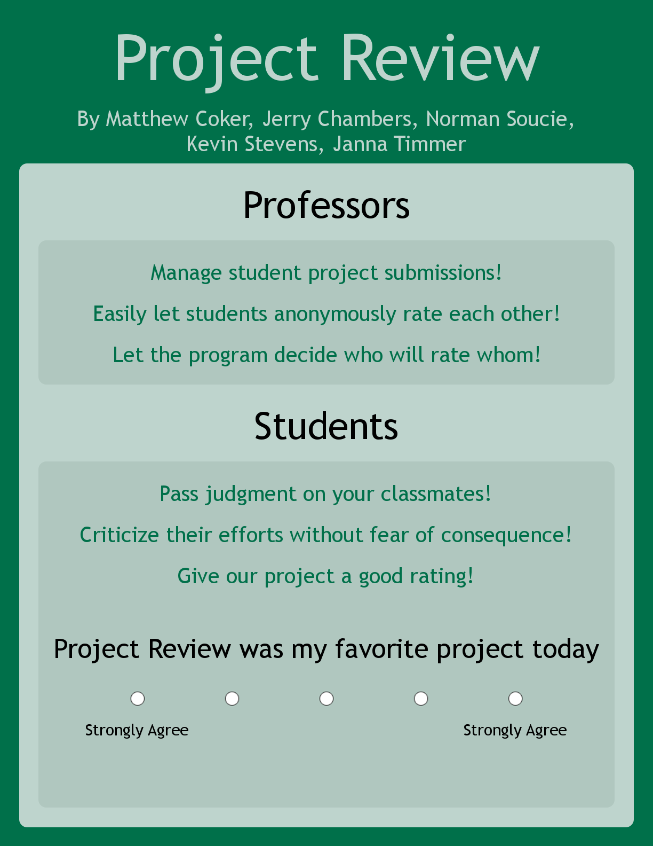

**Project-Review Final Report**

By: Matthew Coker, Kevin Stevens, Janna Timmer, Norman Soucie, Jerry Chambers

**Overview**

Project-Review is a website platform that enables professors to assess their students through a peer review process. It allows a professor to hold multiple classes with students imported from D2L or manual invitation. Using an algorithm that makes sure no two students review each other is essential to making this website’s purpose effective and efficient.

**Screencast**

<https://youtu.be/Pn5CEHVvSYk>

**Features and Functionality**

Log-in Page - Fully Functional

* Allows secure log-in
* Passwords are encrypted inside the database
* Help is a link to the FAQ page

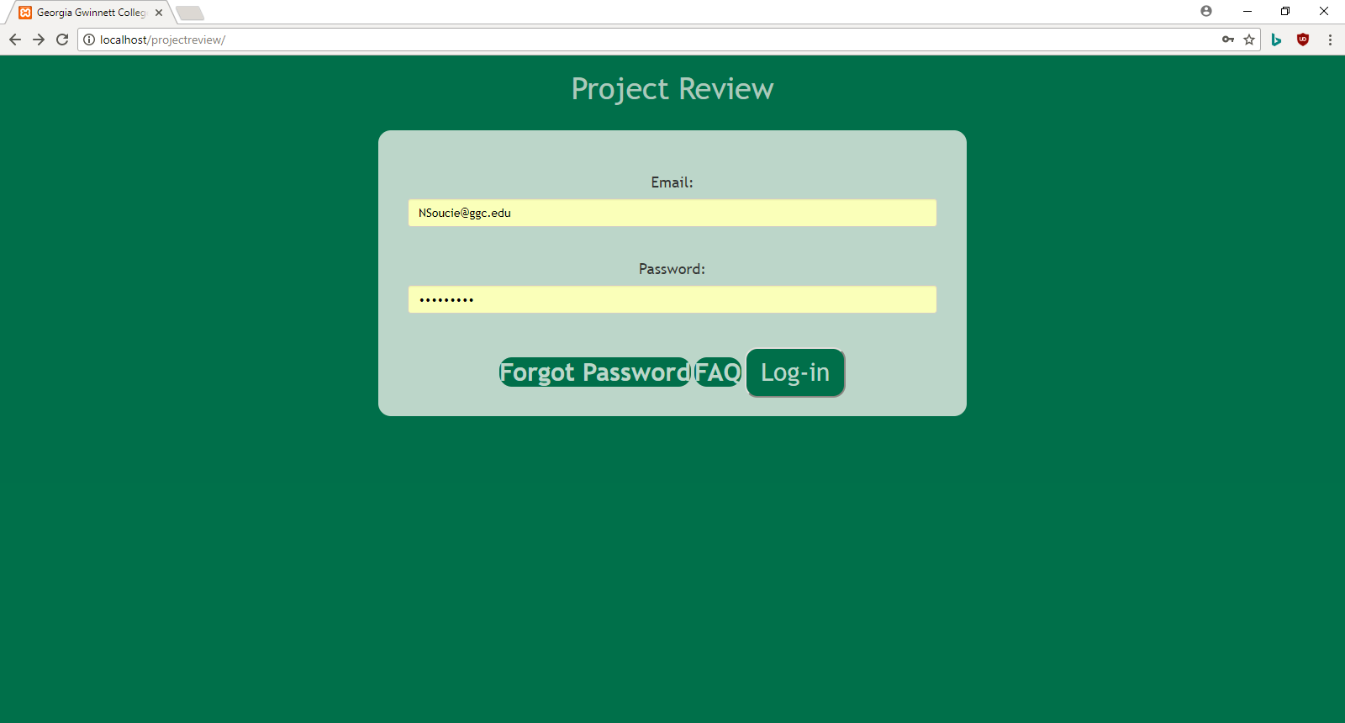

Forgot Password Page

* Students, Professors
  + Can recover their password via email

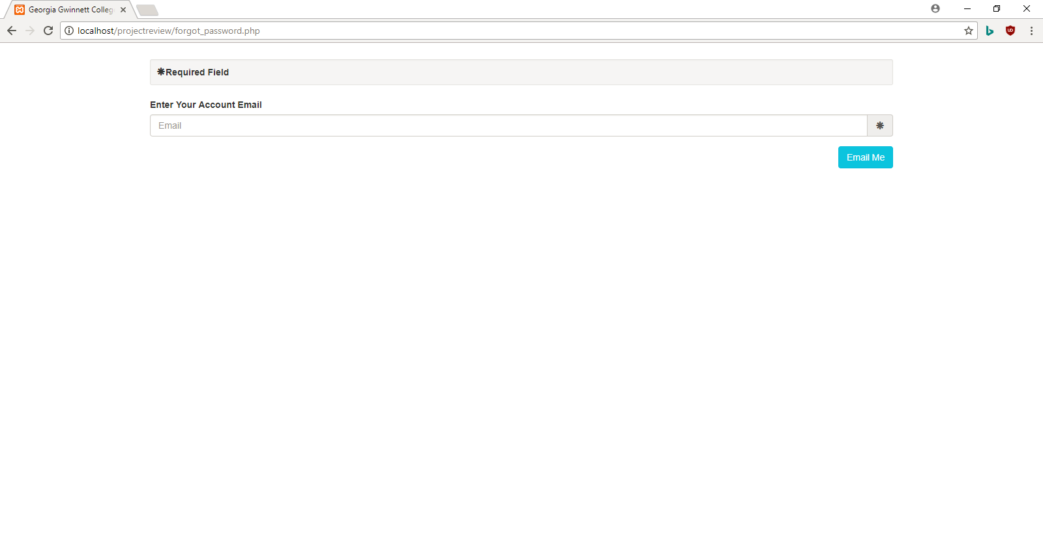

FAQs

Functionality - Fully Functional

* All actors have their FAQs that are tuned towards their individual roles

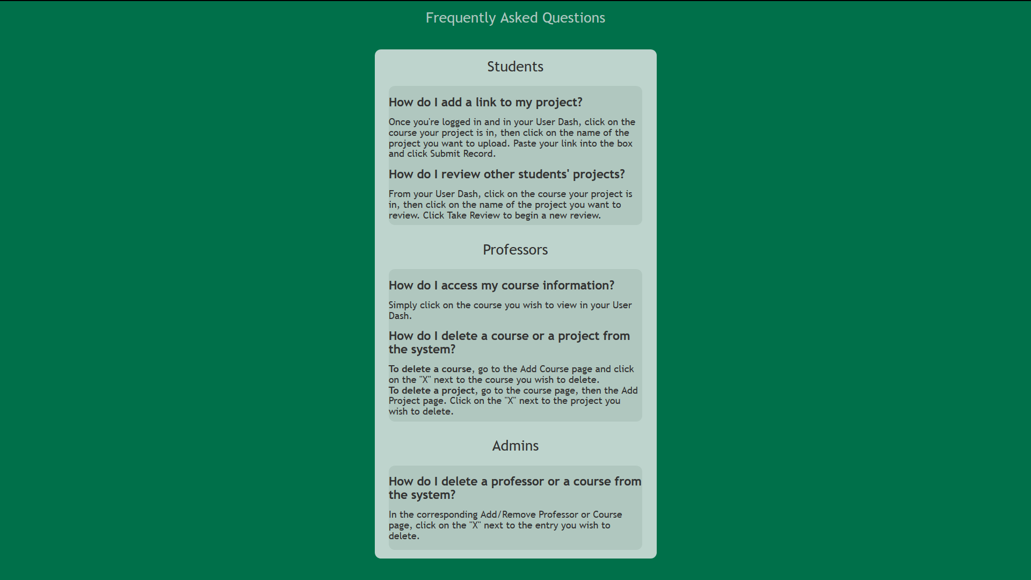

Functionality - Needs more refinement

* The Professor
  + Is able to add/remove courses
  + Is able to participate or teach a course
  + Queries their participating class lists and taught classes
* The Student
  + Is able to enter their courses designated by the professor
  + Queries their class lists from the database

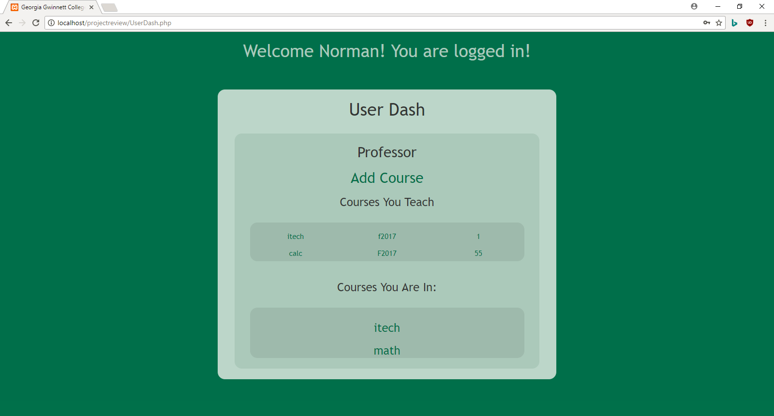

Class Dash - Fully Functional

* Professor
  + Allows the professor to go to the Add/Remove Project Page
  + Allows the professor to go to the Add/Remove Student Page
  + On the professor’s end, it allows them to
* Student
  + Displays all the projects for the class, and from the student side, allows them to go into the Project Dash

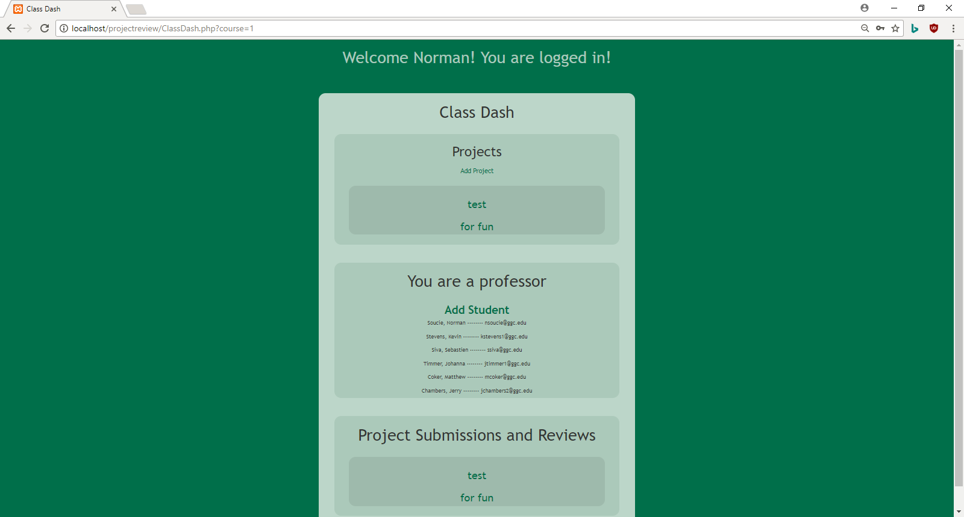

Student Registration Page

* Professor
  + Can add their students via CSV file, enters the data into the database and into their class list for their course.

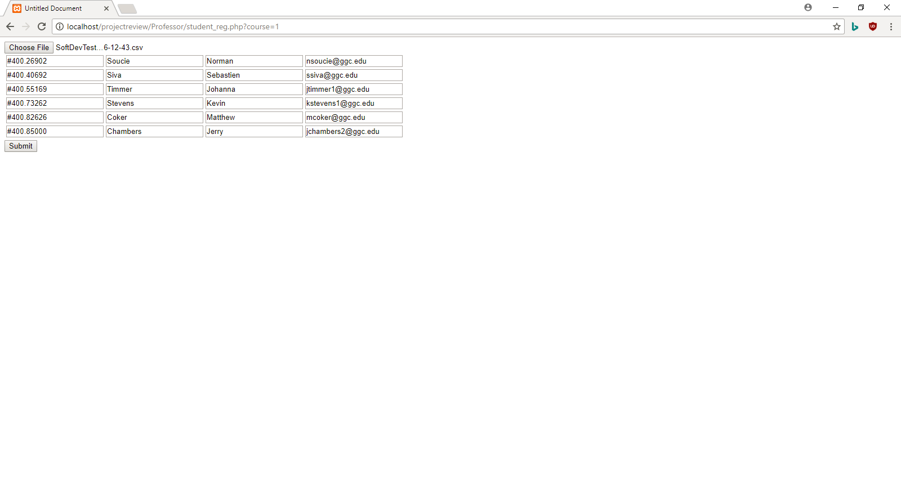

Add Course Page

Functionality - Fully Functional

* Professor
  + Can create courses, using Name, Section, and Semester
  + Can delete courses, an alert will pop-up to warn the Professor about deleting the course

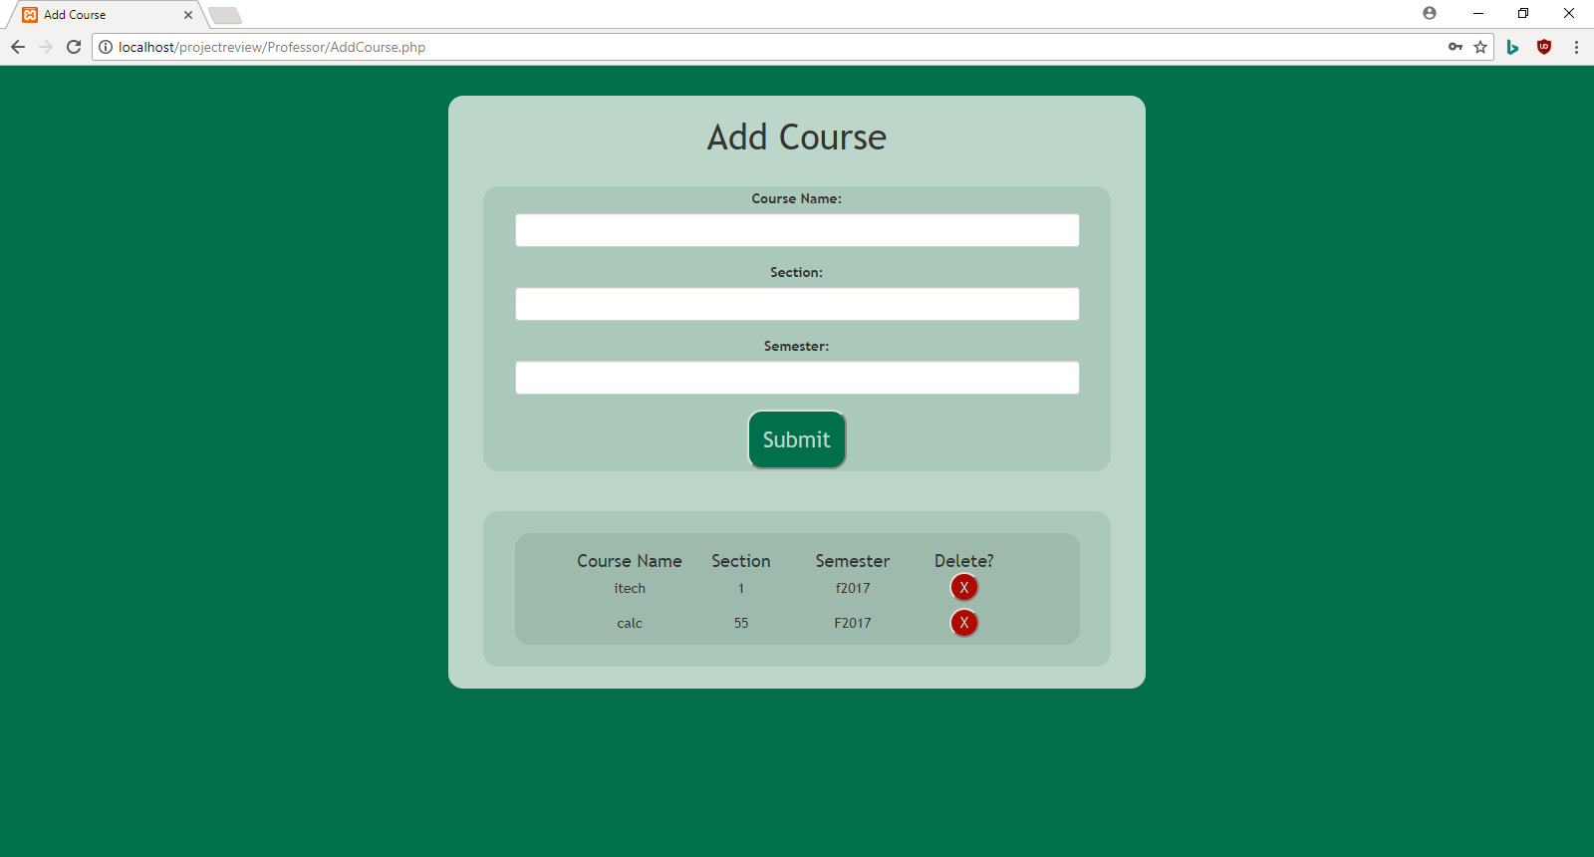

Add Project Page - Fully Functional

* Professor
  + Can add a project with the Name and Date due attribute
  + Can delete projects, an alert pops up to warn the Professor of this action

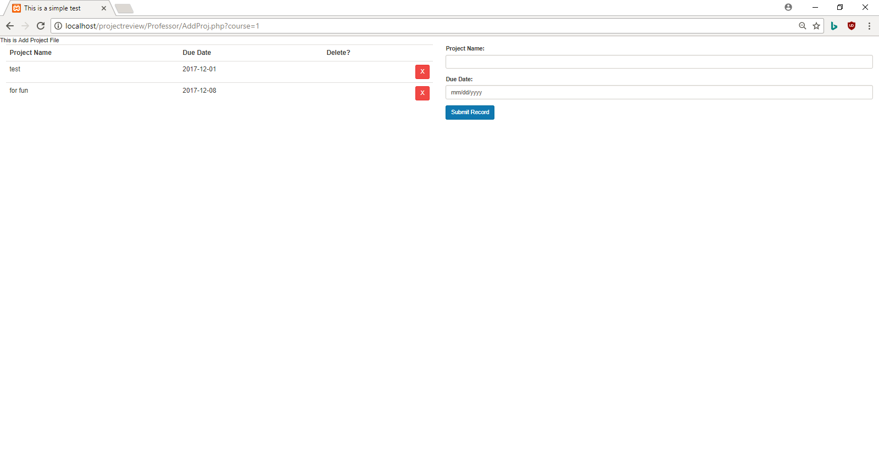

Project Dash - Fully Functional

* Student
  + The student takes a review based on the algorithm, configured so that two different students can not review one another
  + The student can also submit their project links so that when the submissions are reviewed, appropriate projects links reviewed
  + And access their own submission
  + Can look at their previous reviews

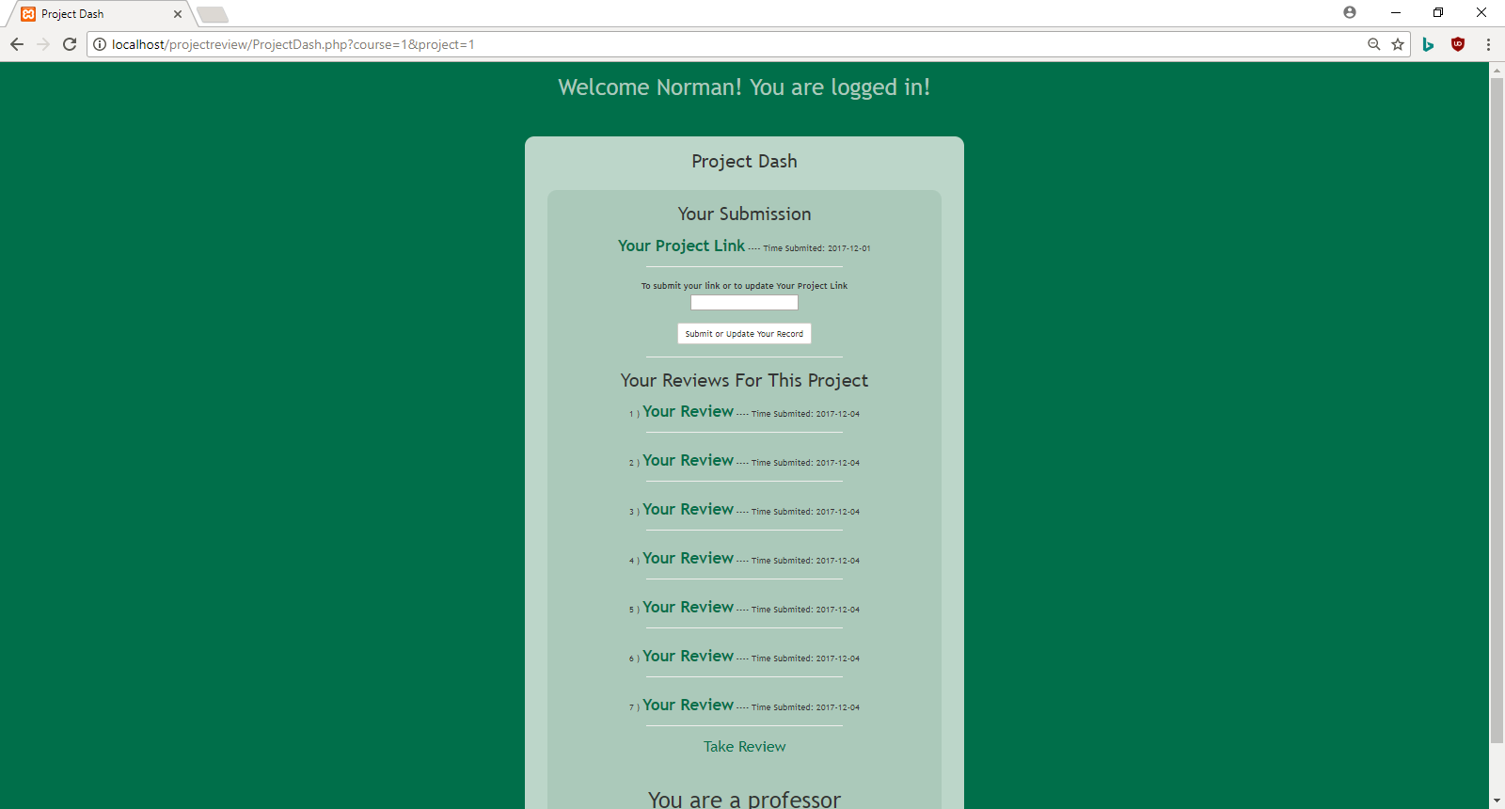

Review Page - Fully Functional

* Student
  + The student can click on the link to view the submission’s project
  + The student can use the form to answer two questions using radio buttons and “constructive criticisms” in the comment box

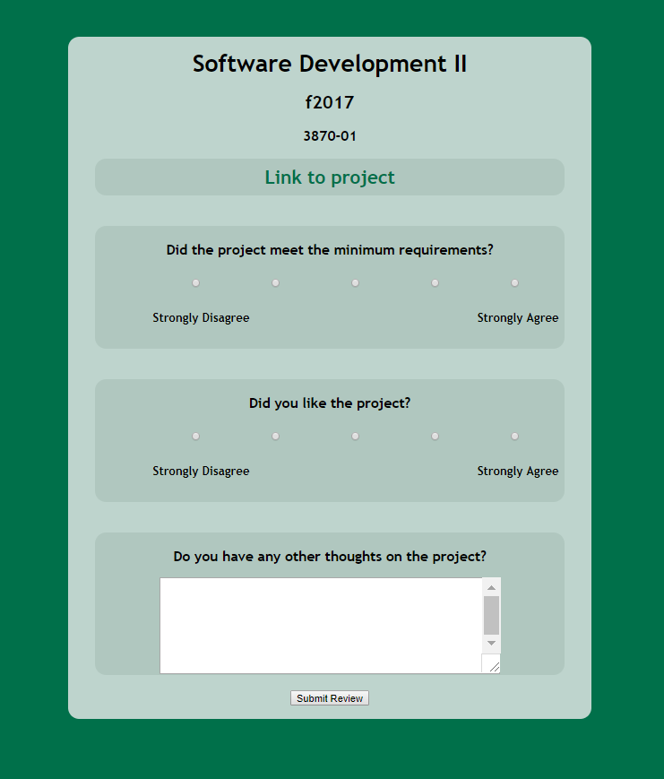

Grade Dash

* Professor
  + Can view every submission by the students in their class
  + Can view every review attached to every submission

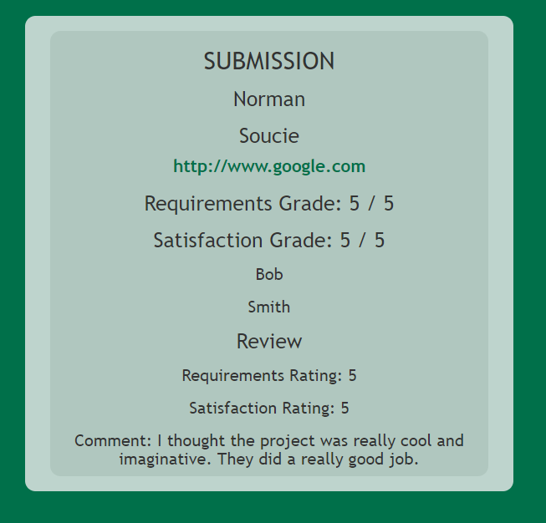

**Usability/Focus Testing**

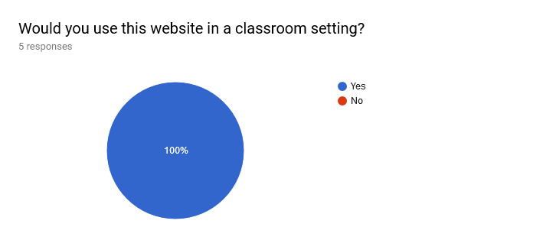

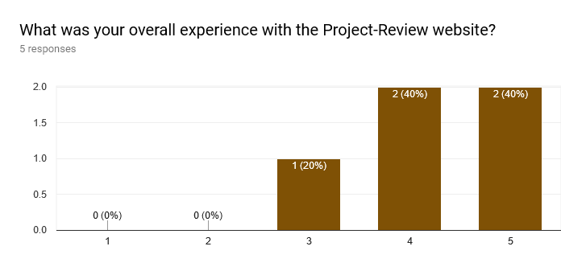

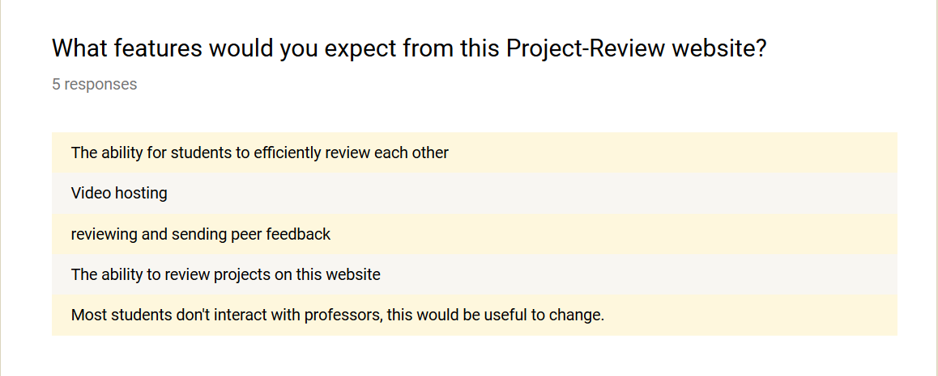

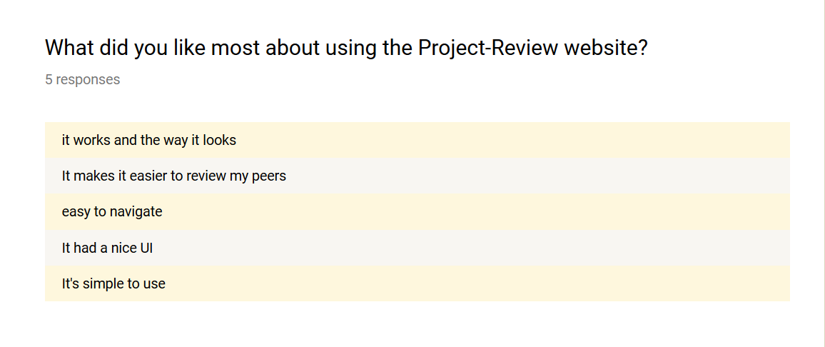

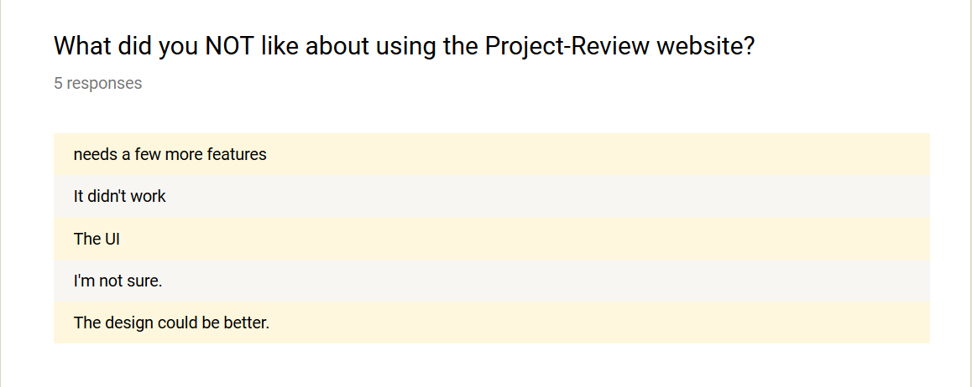

**General**

- No “return to User Dash” button

- No “sign out” button

**User Interaction Conclusion**

All of our survey takers were pleased with our product/website, but mostly the concerns were about the UI and other aesthetics. Otherwise, besides that, a most desired feature was the FTP feature, being the video hosting on the server.

**Remaining Work**

* FTP file hosting
* Export of CSV of student grades
* Editing of the grades through the Grade Dash by the professor

**Known Issues**

* Professor needs to be more carefully distinguished among classes.
* Variables are tossed up using “get” instead of “post”

**Team Members**

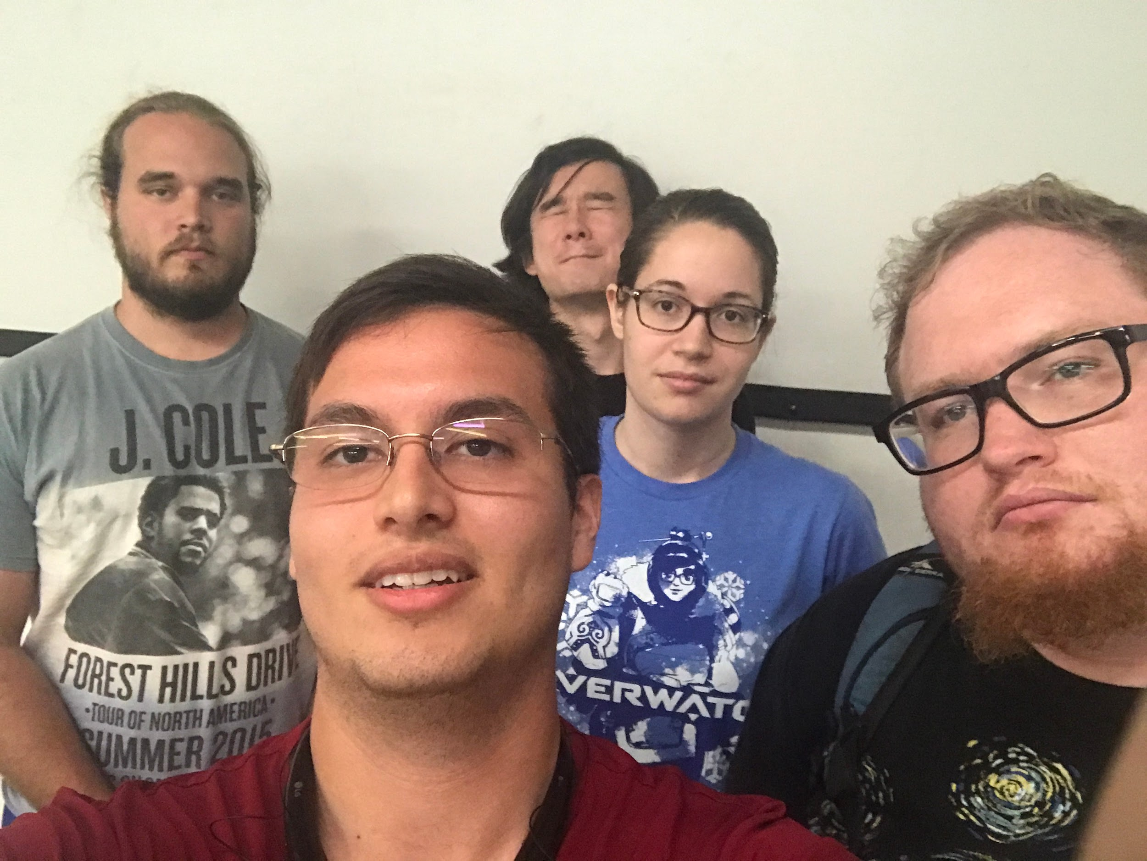

* From Left to Right:
  + Norman Soucie, Matthew Coker, Jerry Chambers, Janna Timmer, Kevin Stevens
    - Norman Soucie - Data Modeler & Lead Programmer
    - Matthew Coker - Team Manager/Client Liaison
    - Jerry Chambers - Testing Lead
    - Janna Timmer - Documentation Lead
    - Kevin Stevens - UI/UX Design

**Our Client**



Dr. Sebastien Siva

* Professor at GGC since 2011
* Teaches programming courses
  + Intro to Programming
  + Game Development
* Likes to make creative projects a part of his courses
  + EarSketch (mixing music with code)
  + Code art (using GUI libraries)
  + Game design
* Looking for an easier/better way for students to look at and review each other’s projects

**Testing**

**Automated Testing:**

* Update of automated testing approach
  + 1. Now logs into the auto-generated user
    2. Future improvements would auto verify the user as a student, professor or admin
* Report code coverage of unit tests
  + 1. Automate features and verify with unit tests
* User testing results and actions taken
  + 1. Actively documenting trial and error

**General**

- “Forgot password” functionality works on actual server but not when running locally, which makes sense because otherwise the code doesn’t actually communicate with the internet to send a password reset email.

- Autogenerate user code needs to be tested across multiple platforms

**Admin : These errors are only on the latest commit and not the one prior to that**

**Possible Desync Issues**

* Undefined index errors displayed on Add/Remove Course (“AddCourse.php”) where you would delete courses; courses not being deleted
* Undefined index errors displayed under section labeled "Courses You Teach"
* Clicking on classes that the admin teaches or is enrolled in leads to a blank ClashDash.php

**Professor**

* Cannot export CSV files containing student names and emails

**Student**

* Cannot peer review teacher for giving bad assignments

**Installation**

This website doesn’t need to be installed it can be accessed at <http://souciernd.com/ProjectReview/>

**Developer Installation**

For those who decide to continue our work, we would recommend that you first install XAMPP first and foremost. Then download the repository and move the repo to the htdocs folder of XAMPP near the root directory. In the repository, then go to user documentation and then the SQL files, so that you have data to experiment with. When running our website locally, you need to make sure that the Apache server and MySQL DB has already been started.

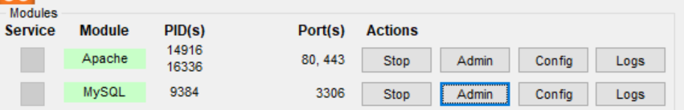

Go ahead and create the ggc_project_review schema.

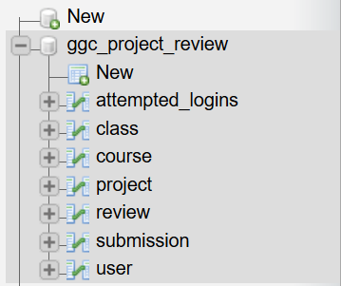

And in order for the website to access data, the php files required user privileges to be set up, the user’s name to access the data will be “ggc_user”, and the associated password will be just “ggc”.

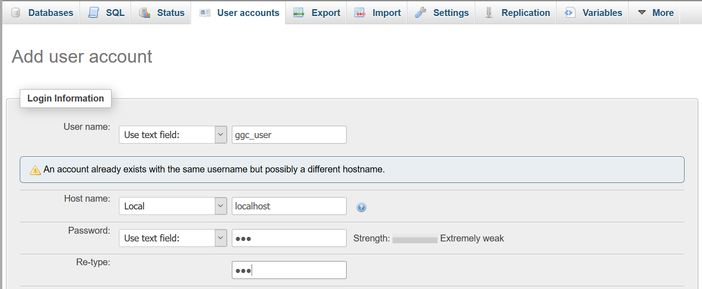

And before the account is created the ggc_user must have Data access privileges like so. Everything can be left at default.

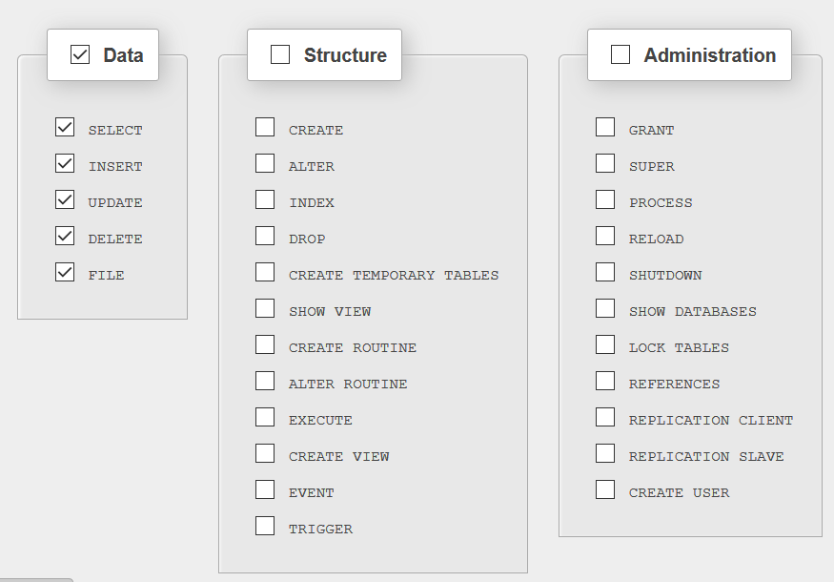

To import SQL code, choose this option explained in the picture. Click on import then the actual file itself.



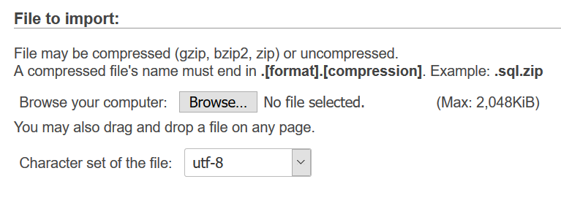

**DOCUMENTATION**

<https://github.com/soft-eng-practicum/project-review>

To access the project documentation, in the repo there is a folder called “Project Documentation”. All of our SQL files, schema, documentation, and so on and so forth are. User instructions (FAQ page) can also be found through the Help button on the website.

**LICENSE AGREEMENT**

**S-Dawg  
Intellectual Property and Licensing Agreement**    
DO WHAT THE FUCK YOU WANT TO PUBLIC LICENSE   
  
This Intellectual Property Contribution and Assignment Agreement (the “Agreement”) is made of 4 December 2017 by and between the members of S-Dawg (the “Company”), Dr. Sebastien “Seabass/S-Dawg” Siva (the “Partner”), Dr. Cengiz Gunay (the “Sponsor”), and you (the “Licensee”)

1. **Intellectual Property Assignment:** Both parties have agreed that the members of Company will release into the public domain as open source software.

THE WORK (PROJECT-REVIEW) IS PROVIDED UNDER THE TERMS OF THIS WTFPL LICENSE.

**GENERAL LICENSE TERMS AND CONDITIONS**

Version 2, December 2004   
  
 Copyright (C) 2004 Sam Hocevar <sam@hocevar.net>

Everyone is permitted to copy and distribute verbatim or modified copies of this license document, and changing it is allowed as long as the name is changed.   
  
 DO WHAT THE FUCK YOU WANT TO PUBLIC LICENSE   
TERMS AND CONDITIONS FOR COPYING, DISTRIBUTION AND MODIFICATION   
  
 0. You just DO WHAT THE FUCK YOU WANT TO.

